Consult the video demonstrates each step:
https://screenrec.com/share/OwWT7rckQN

1. Install Python
Download and install python for the respective OS: https://www.python.org/downloads/

2. Install respective libraries
Run these commands 1 by 1 on powershell
pip install pandas
pip install openpyxl
pip install aspose-cells

4. Download Selenium Web Driver Approrpriate version to your chrome and paste it in the project as it has been given already:
https://sites.google.com/chromium.org/driver/

5. Run the script
1. Open powersell
2. Copy this project path
3. type 'cd', space and paste the copied path in the powershell and press Enter
4. type 'python script.py' and press Enter
5. now it will ask for the message

6. Now the program will start sending messages

7. You can edit the friends list yourself but keep inline the format, no empty rows, it can cause problems for the program
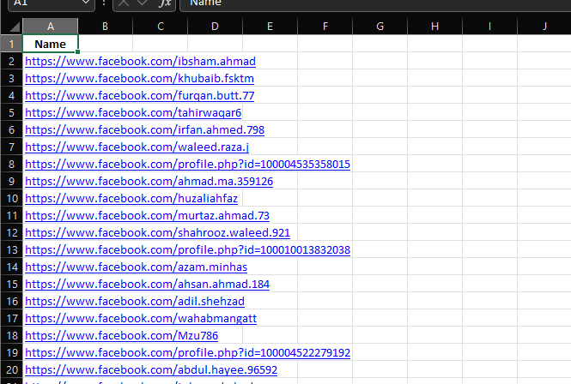
8. Buttons functions as said by you
